Workflow & Prompts - Below the Waterline
A technical breakdown of the generative pipeline, video parameters, seed specifications, and exact generation prompts for the short documentary production Below the Waterline.
Workflow Overview
The technical pipeline utilizes AI-driven generative video and audio models coupled with professional post-production editing for final color, audio mixing, and assembly.

Pipeline Component | Specification / Tool | Parameters
Video Model | Lightricks LTX-2.3 | Frame Rate: 25 fpsDuration: 5.0s per shotResolution: 1280x720
Audio Model | FL Chatterbox Multilingual TTS | High-fidelity voice synthesis
Editing & Assembly | DaVinci Resolve | Master timeline assembly, audio sync & grade

Shot Breakdown & Generation Prompts
Shot 1
- Seed: 137197712595680
- Prompt: Wide high angle shot of a peaceful traditional Dutch polder landscape with green fields, cows, canals, and a windmill under a bright blue sky. Cinematic, realistic, highly detailed, 8k live-action footage.
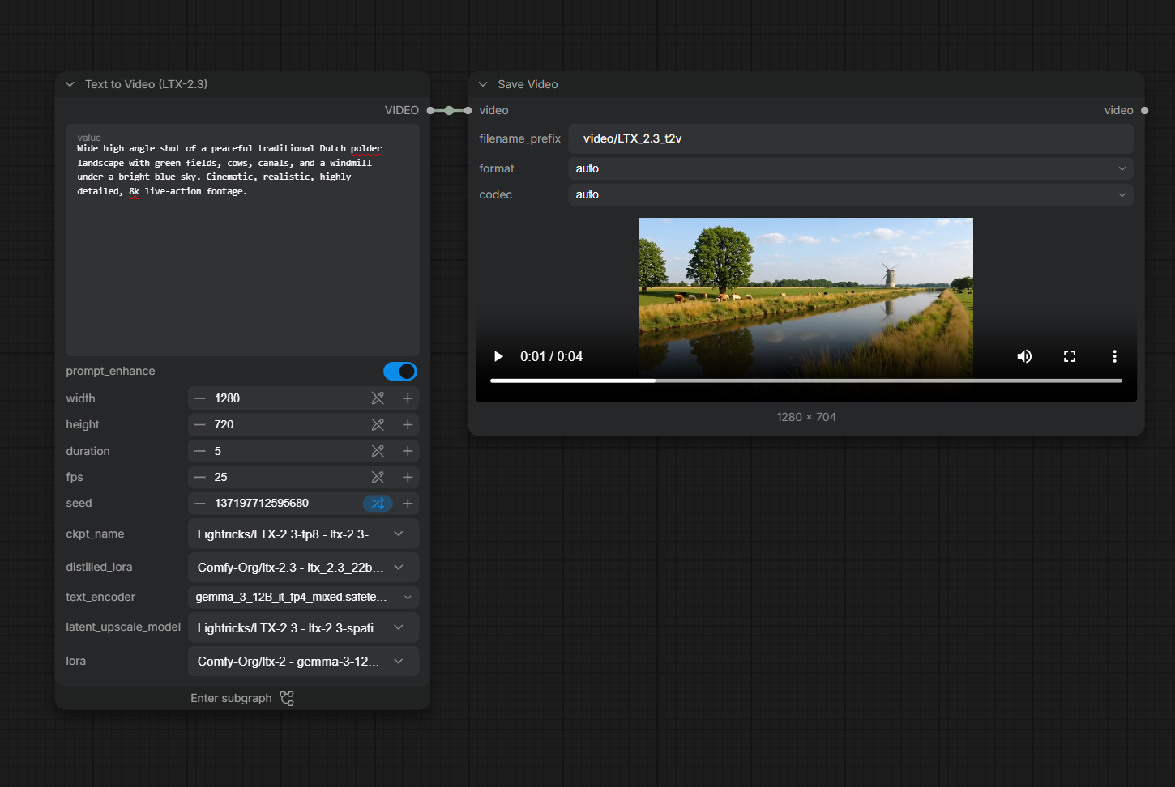

Shot 2
- Seed: 102781703137948
- Prompt: Underwater perspective in a Dutch canal, looking up toward a dike embankment showing low polder land. Cinematic, realistic, highly detailed, 8k live-action footage.
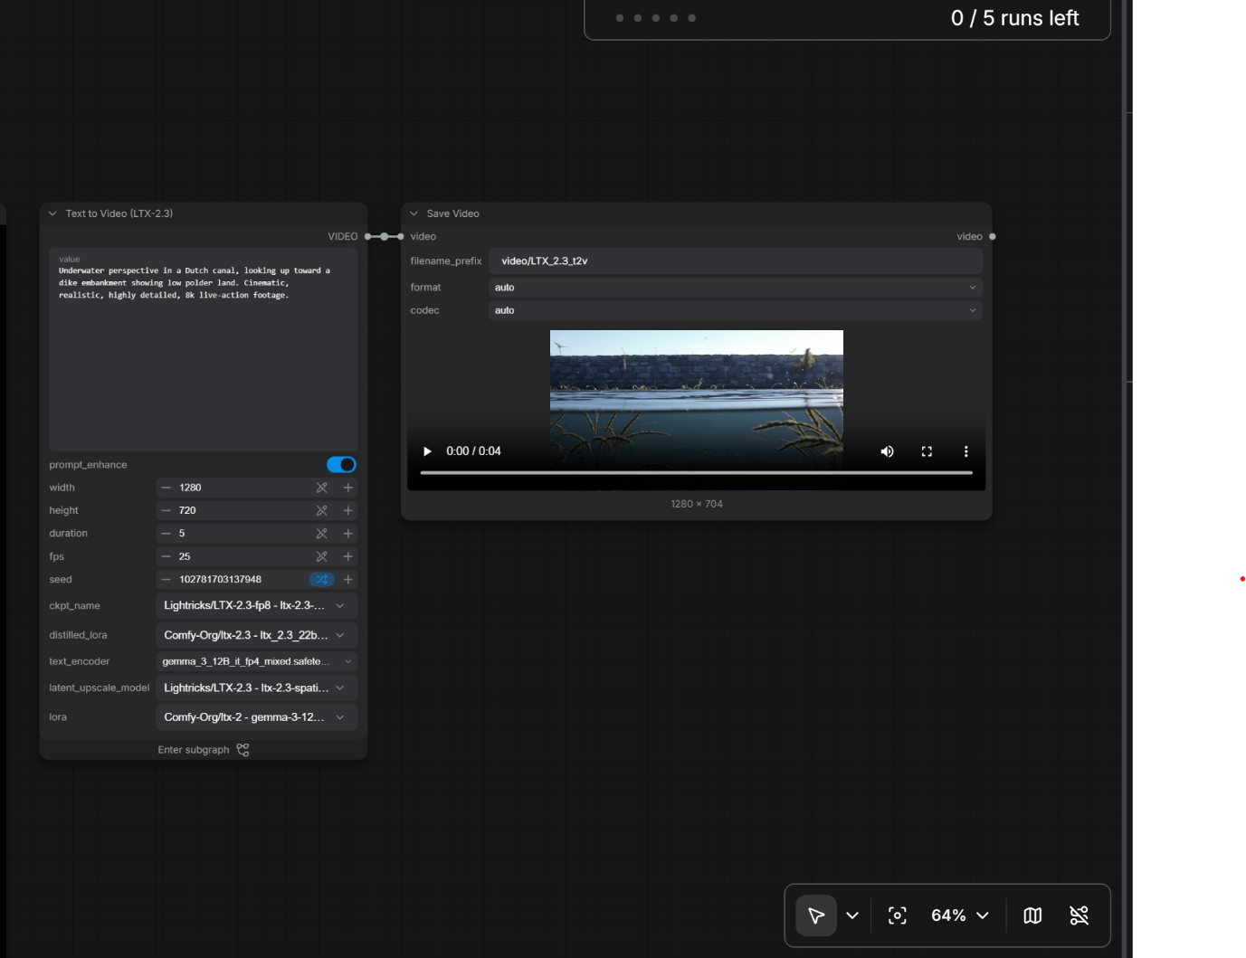

Shot 3
- Seed: 385551756531857
- Prompt: Fast dark storm clouds gathering over the Dutch countryside, heavy rain pouring down, strong winds blowing trees. Cinematic, realistic, highly detailed, 8k live-action footage.
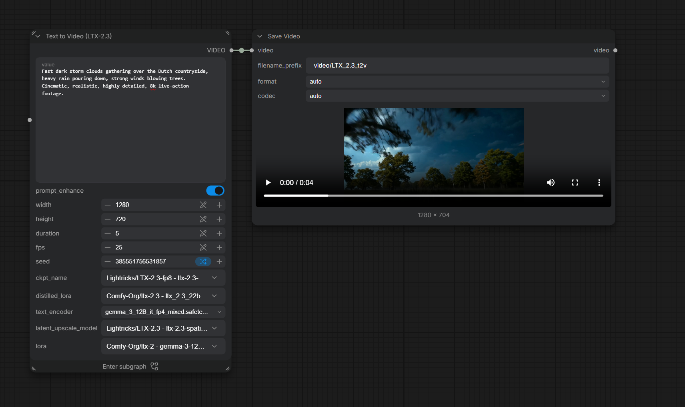

Shot 4
- Seed: 284645288266084
- Prompt: Dramatic close-up of stormy ocean waves violently crashing against a massive Dutch coastal sea dike under gray overcast skies. Cinematic, realistic, highly detailed, 8k live-action footage.
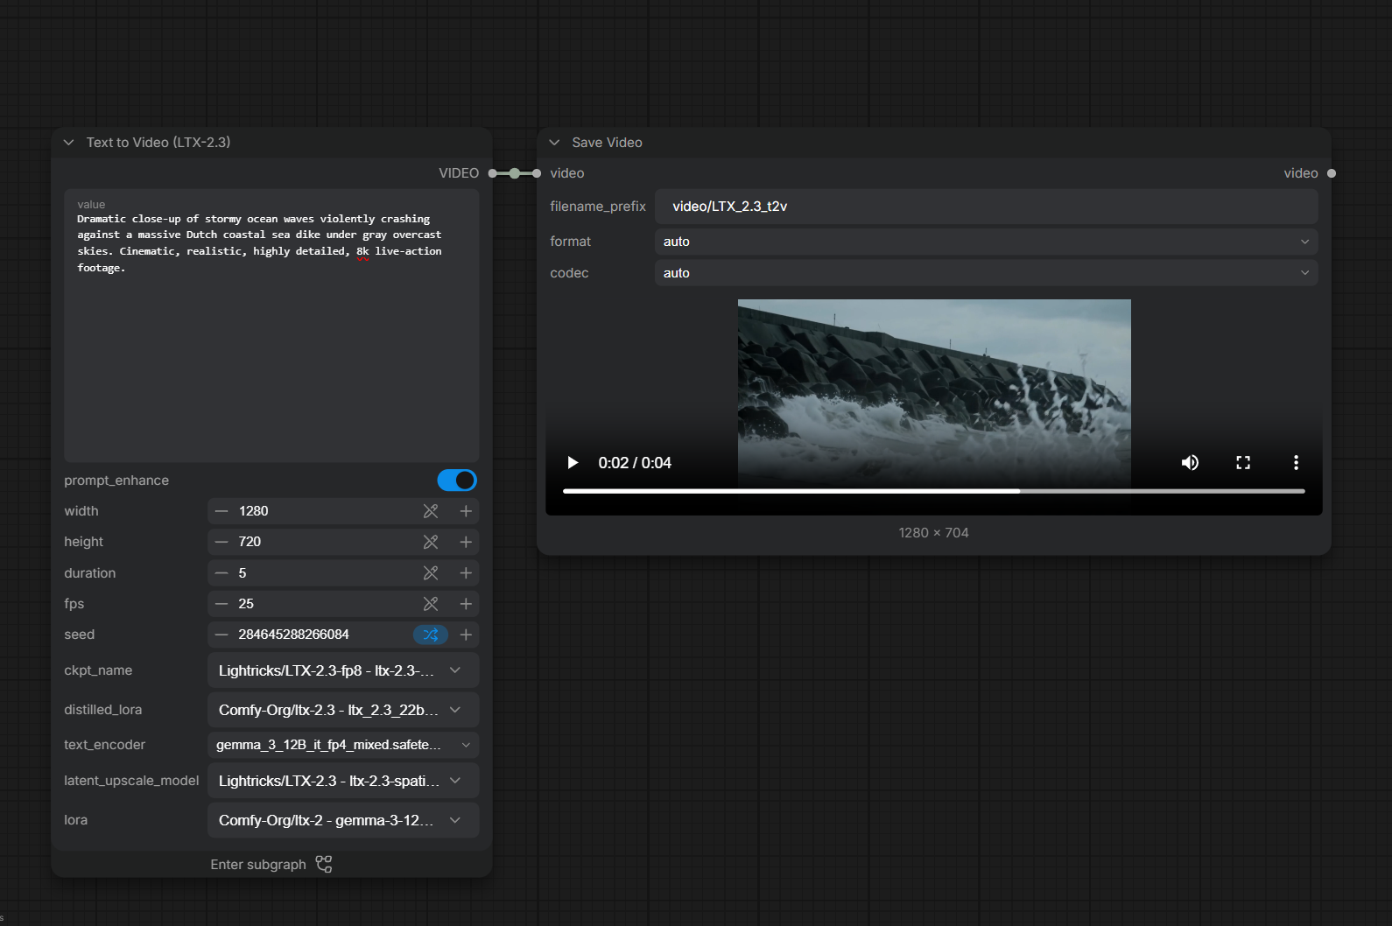

Shot 5
- Seed: 939380416967638
- Prompt: Photorealistic cinematic live-action footage of a low-lying Dutch peatland landscape, flat green farmland beside narrow drainage canals, dark peat soil visible along the edge of the field, subtle signs of soil settlement and sinking ground near the canal, drainage ditches crossing the landscape, low-lying agricultural land extending toward a perfectly flat Dutch horizon, realistic grass and vegetation gently moving in the wind, calm water in the drainage channels, overcast natural daylight, slow smooth lateral camera movement revealing the relationship between the drained land and surrounding water, realistic environmental documentary cinematography, physically realistic Dutch landscape, highly detailed natural textures, serious but not catastrophic atmosphere, no flooding disaster, no destruction, no collapsing buildings, no apocalypse, no people, no text, no logos, no watermark
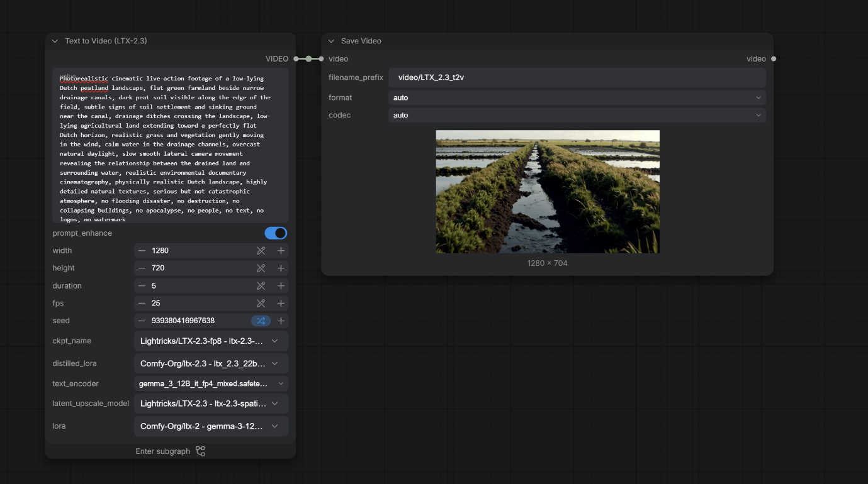

Shot 6
- Seed: 677567799682024
- Prompt: Photorealistic cinematic live-action footage of a modern Dutch residential neighborhood designed for climate adaptation after rainfall, shallow water temporarily stored in a landscaped urban retention area beside residential buildings, raised pedestrian walkways, rain gardens, green spaces, narrow canals, climate-resilient architecture, permeable landscaped areas, realistic Dutch bicycles and residential streets, fresh wet surfaces reflecting soft daylight, residents walking and cycling safely in the distance, sunlight beginning to break through clouds, hopeful but realistic atmosphere, smooth slow cinematic camera movement through the neighborhood, realistic environmental documentary cinematography, highly detailed natural textures, physically realistic Netherlands setting, no disaster, no flooding destruction, no abandoned buildings, no apocalypse, no extreme water levels, no text, no logos, no watermark
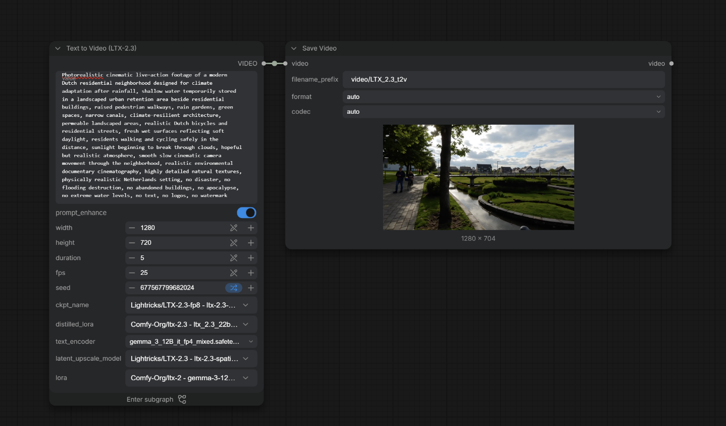

Shot 7
- Seed: 776540022117074
- Prompt: Modern Dutch floating houses moving gently on water in a green sustainable neighborhood, climate-adaptive architecture. Cinematic, realistic, highly detailed, 8k live-action footage.
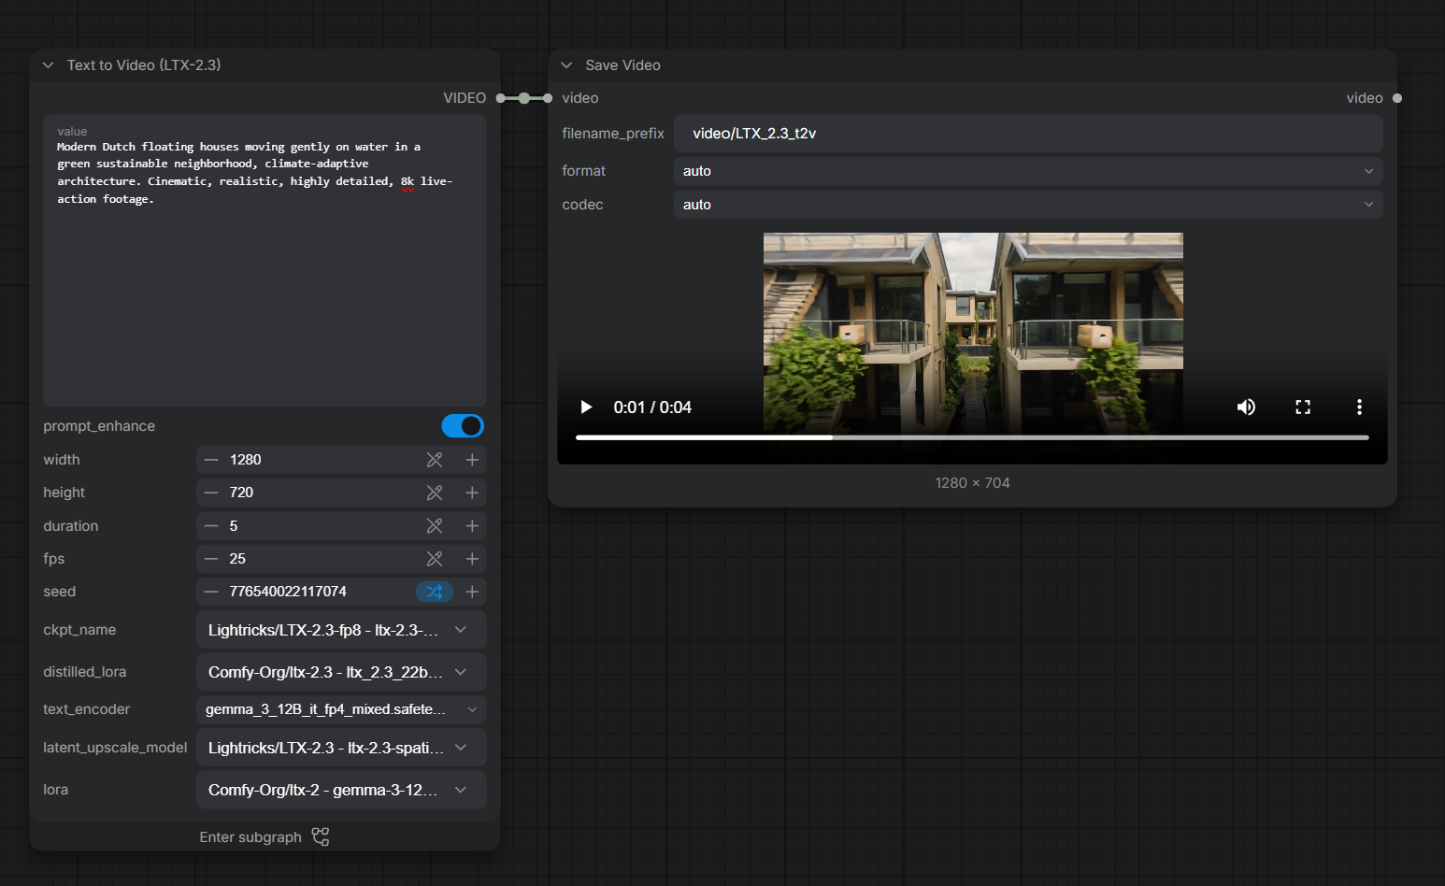

Shot 8
- Seed: 534662479964753
- Prompt: Aerial cinematic shot of a modern water-resistant Dutch city with green rooftops, wide canals, and water retention basins on a sunny day. Cinematic, realistic, highly detailed, 8k live-action footage.
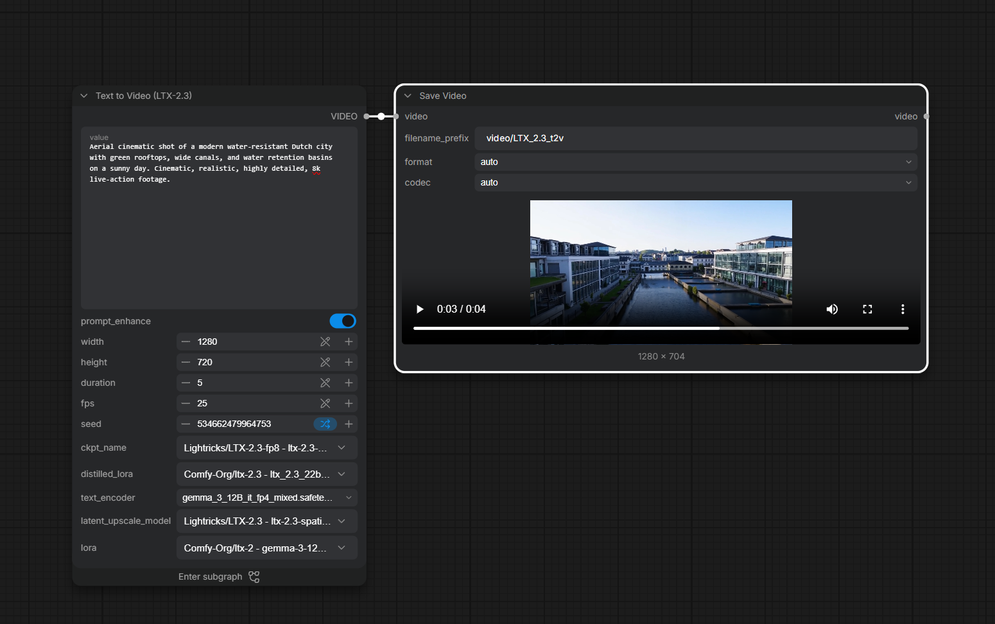

Shot 9
- Seed: 233176656929555
- Prompt: Minimalist clean Dutch polder landscape under daylight. with text in the middle of shot saying "BELOW THE WATERLINE". Cinematic, realistic, highly detailed, 8k live-action footage.
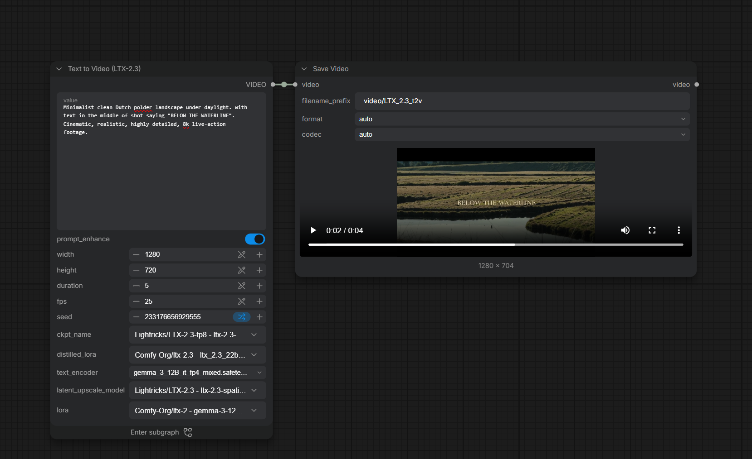

Voiceover & Audio Specifications
- Voice Generation Seed: 4248668765
Script / Audio Prompt
"The Dutch polders—a peaceful landscape shaped by generations of living with water. But today, our story reaches a critical turning point. As sea levels rise and the very ground beneath us slowly sinks, severe storm clouds gather on the horizon. Over ten million lives and two-thirds of our economy are directly at risk. Yet, giving up is not in our nature. From amphibious floating homes to climate-resilient cities, we adapt, we innovate, and we rebuild. The water is coming... but we choose to build our future above it. below the waterline"
